Paper Template for the 6th International
Symposium on Space Sailing (ISSS 2023)
First C. AUTHOR^{a,*}, Second N.C. AUTHOR^{b}
ªInstitute/Department, Agency/University/Company, City, Country
^{b}Institute/Department, Agency/University/Company, City, Country
Abstract
This is the manual for how to prepare your paper for the 6th International Symposium on Space Sailing (ISSS 2023). All papers written in Word should follow this template and use the styles therein. The Abstract should be placed here.
Keywords: keyword 1, keyword 2, keyword 3, keyword 4, keyword 5 (maximum 6 keywords)

Nomenclature
V Velocity
X Position
Superscripts
(f) Final
Subscripts
i i^{th} element

Nomenclature (if needed)
The heading “Nomenclature” should be in style “Heading 1 no numbering”. A nomenclature section can be provided if it is needed. Nomenclature definitions should not appear again in the text.

Introduction
These guidelines include a complete description of the fonts, spacing, and related information for your paper. Please pay attention to keep the original format of this Word file. The submission of a paper is not mandatory to give a talk. All submitted papers will be made available to all participants in electronic form. Please make sure that your submission is no longer than 8 pages. All manuscripts are to be submitted by 9 June 2023.

Formatting Your Paper
Table 1 shows the page layout and the general format. The authors do not need to put their paper number and the copyright onto their paper. It will be put later onto the papers by the ISSS 2023 Editorial Board.

Table 1. Format of the paper. Captions in style “Caption”
 | Value
Paper Size | A4
Max. number of pages | 16

Word styles are preset for you to be used in each part of the paper, and will be described in the next sections. Please use these preset styles for formatting (see Fig. 1).

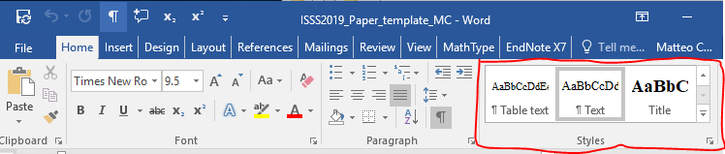
Fig. 1. Word styles.

Front Matter

Title
The title should be brief and concise. The title should be in style “Title”. Please use the APA title case capitalization style (you can use the website https://capitalizemytitle.com to capitalize your title correctly). Please try to make all lines of the title approximately the same length (use Shift+Enter to break the line(s)).

Author Name(s) and Affiliation(s)
Author names are to be in style “Authors”. The full name is preferred. Only primary contributors should be listed in the authors list; others may appear in the acknowledgments.
Affiliations should follow on the next paragraph, and in style “Affiliation”.

Abstract
The abstract should be 100 to 200 words, written as a single paragraph and in style “Abstract”.
The abstract should be a summary and complete in itself. It should indicate the subjects dealt with in the paper and should state the objectives and the results of the investigation.

Keywords
Please do not specify more than five keywords. They should fit into a single line.
The keywords should be in style “Keywords”. Begin with “Keywords: ” in italic.

Article Body
Type your main text in style “Text”. All paragraphs will be indented on the first line and the text fully justified.

Nomenclature
A nomenclature section is required for papers containing more than a few symbols.
The heading “Nomenclature” should be in style “Heading 1 no numbering”.
The nomenclature list should be in style “Nomenclature” and for each line include a symbol, a tab, and its definition.
Please use standard symbols whenever possible.

Introduction
The paper must include an Introduction – a brief assessment of prior work by others and an explanation of how the paper contributes to the field.
Use style “Heading 1” for the introduction heading, which should be numbered “1.”.

Main Headings
Main headings should be formatted in style “Heading 1”. This will add numbering automatically.

Sub-Headings
Sub-headings should be in style “Heading 2”. This will add numbering automatically.

Sub-Subheadings
Sub-subheadings should be in style “Heading 3”. This will add numbering automatically. Please avoid using more than three levels of headings.

Figures
Figure captions are formatted in style “Caption”. Use “Fig. 1. Caption here”. Only the first letter of each sentence is capitalized. The figure captions appear below the respective figures. Leave one empty line between the figure and the preceding text, and between the caption and the subsequent text.
You can use Word’s automatic captioning and referencing tools. Make sure that all inserted pictures have “Wrap text” property set to “Align with text”.
See Fig. 2 for example.

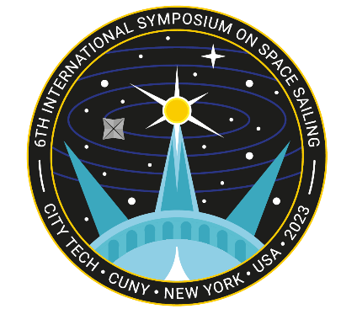
Fig. 2. The ISSS 2023 logo. The figure captions should be below the figure and in style “Caption”.

Tables
Table captions should be formatted in style “Caption”. Use “Table 1. Caption here”. Table captions are above respective tables.
Table text should be formatted in style “Table text”. Leave one empty line between the caption and the preceding text, and between the table and the subsequent text.
You can use Word’s automatic captioning and referencing tools. Make sure that all inserted tables have the “Text wrapping” property set to “None”. See for example Table 1.

Equations
Equations should be centred, with a sequential number in round brackets flush right. Use the style “MTDisplayEquation”, and use a tab, the equation, a tab, the number. For example:
The base (full) size for symbols in equations should be 10 points
Please refer to equations using “Eq. ”, not “Equation (1)” or just “(1)” in the text.

Bulleted and Numbered Lists
Bulleted lists can be created using the style “Bulleted”:
- Vanilla
- Chocolate
- Strawberry
Numbered lists can be created using the style “Numbered”:
- Injection
- Transfer
- Capture

Conclusions
The conclusions of your work should be clearly stated.

References and Citations
References should be listed in order of appearance, using sequential numbering between square brackets, such as in Ref. [1]. Use the style “References” for the bibliography, which will also add a sequential number. You can use Word’s cross-referencing tools for in-text citations.
The reference style of articles [1], conference papers [2], books [3], book chapters [4], reports [5], and websites [6] is shown in the References section.
The heading “References” should be in style “Heading 1 no numbering”.

PDF File Conversion
- Avoid file sizes larger than 20 MB.
- Check your PDF before submission.
- Do not use document security features.

Acknowledgments (if needed)
The heading “Acknowledgements” should be in style “Heading 1 no numbering”.
We appreciate the authors’ efforts to fully follow this template.

References
- R.L. Forward. Roundtrip interstellar travel using laser-pushed lightsails. Journal of Spacecraft and Rockets, 21(2):187–195, 1984. doi: 10.2514/3.8632
- C.G. Sauer. Optimum solar-sail interplanetary trajectories. San Diego, USA, August 1976. AIAA/AAS Astrodynamics Conference. Paper 76-792. doi: 10.2514/6.1976-792
- C.R. McInnes. Solar Sailing. Technology, Dynamics and Mission Applications. Springer-Praxis Series in Space Science and Technology. Springer-Praxis, 1999.
- B. Dachwald. Solar sail dynamics and control. In R. Blockley and W. Shyy, editors, Encyclopedia of Aerospace Engineering, pages 3139–3152. Wiley, Chichester, 2010. doi: 10.1002/9780470686652.eae292
- J.L. Wright. Solar sailing – evaluation of concept and potential. Technical report, Battelle Columbus Laboratories, Columbus, Ohio, 1976. BMI-NLVP-TM-74-3.
- The Planetary Society: What is a solar sail? http://www.planetary.org/explore/projects/lightsail-solar-sailing/what-is-solar-sailing.html. Accessed: 2019-03-05.

Corresponding author, c.author@gmail.com

